Procedure for
Taking Assets Offsite

Security Classification: Protected

Document Ref. ISMS17007
Version: 1.0
Draft 1

Document Author: Cybersecurity Unit

Document Owner: NCS/ TMP

Revision History

Version | Date | Change Number | Summary of Changes

Document Review

Date of Next Scheduled Review

Distribution

Name | Title

Approval

Name | Position | Signature | Date

Contents

1 Introduction 5
1.1 Risks Addressed 5
1.2 Scope 5
1.3 Related Documents 5
1.4 Purpose 5
2 Assets Covered by this Procedure 6
3 Procedure for Taking Assets Offsite 7
3.1 Procedure Diagram 7
3.2 Request Permission to Take an Asset Offsite 8
3.3 Confirm Details Provided 8
3.4 Obtain Permission from Asset Owner 8
3.5 Inform Requester of Decision 8
3.6 Inform Reception Security 9
3.7 Requester Takes Asset Offsite 9
3.8 Requester Returns Asset 9

Introduction

Risks Addressed

This document describes a control that was identified in the Risk Treatment Plan (document reference ISMS06004) to address the following risks:

Reference | Description of Risk

Scope

This control applies to all systems, people and processes that constitute the organisation’s information systems, including board members, directors, employees, suppliers and other third parties who have access to Project Management Office (PMO) systems.

Related Documents

The following policies and procedures are relevant to this document:

- ISMS12002 Mobile Computing Policy
- ISMS12003 Teleworking Policy
- ISMS13001 AUP and Personal Commitment Statement
- ISMS14001 Information Asset Inventory
- ISMS14002 Information Security Classification Guidelines

Purpose

As part of compliance with the PMO Information Security Policy, there may be circumstances where assets will need to be taken offsite. This document sets out how this should be done and what information should be recorded about the asset before and after it is removed.

Assets Covered by this Procedure

In order to protect sensitive information held by the PMO it is essential that the removal of assets from sites be controlled.

Under no circumstances should assets containing classified information be removed from site in a manner other than that described in this procedure. To do so would represent a security incident which may have serious consequences for both the organisation and the individual responsible.

The types of assets covered by this procedure include the following:

- Physical
  - Personal computers
  - Laptops and notebooks
  - Tablet computers
  - USB memory sticks
  - Hard disks
  - CDs and DVDs
  - Solid state storage devices
  - Phones

- Information
  - Assets classified as Confidential
  - Assets classified as Restricted

As technology develops there will be further types of devices and media that are capable of storing sensitive data. Such devices and media will also fall under the remit of this procedure.

Note: although encryption offers a higher level of protection against information being read by unauthorised persons, the fact that the data held on a device or on media is encrypted does not exempt it from this procedure.

Procedure for Taking Assets Offsite

Procedure Diagram

The procedure for taking assets offsite is shown in the diagram below.

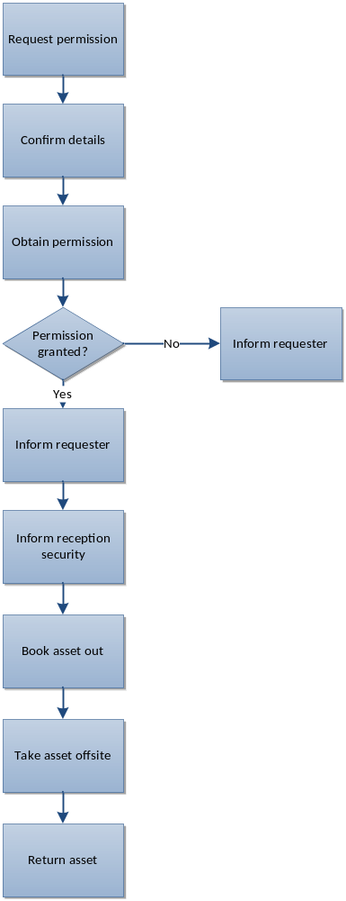

Figure 1 – Procedure for Taking Assets Offsite

Request Permission to Take an Asset Offsite

Requests to take assets offsite should be logged with the Cybersecurity Unitvia telephone, email or online. It is the responsibility of the person taking the asset offsite to inform the Cybersecurity Unitof the request.

The following details should be provided:

- Requester name, role, department and contact details
- The asset to be taken offsite
- The serial number of the asset and/or device containing the asset (e.g. PC), if available
- The classification of the asset
- The current location of the asset
- The location the asset is to be taken to
- The reason for the asset needing to be taken offsite
- When the asset will be taken offsite
- The identity of the person(s) who will be taking the asset offsite
- Who will be responsible for the asset whilst it is offsite
- When the asset will be returned

This information may be stored on the service desk record raised at the time of the request.

Confirm Details Provided

Once received from the requester, the Cybersecurity Unitwill check the details of the asset in the asset inventory against those provided to verify accuracy and completeness. The owner of the asset should be identified.

Obtain Permission from Asset Owner

The Cybersecurity Unitwill then contact the asset owner (or nominated deputy) to request permission for the requester to take the asset offsite. The details of the request as provided should be given.

The asset owner (or nominated deputy) will then decide whether to give permission for the asset to be taken offsite. Further detail may be sought from the requester where necessary.

Inform Requester of Decision

The Cybersecurity Unitwill then inform the requester whether permission has been granted.

If permission has been denied, this fact will be recorded on the request record and the request closed.

If permission has been granted, the requester will be given instructions to book the asset out at reception when leaving site, including the reference number of the approved request.

Inform Reception Security

The Cybersecurity Unitwill inform reception security that an asset will be booked out and the following detail provided:

- The reference number of the approved request
- Requester name, role, department and contact details
- The asset to be taken offsite
- The serial number of the asset and/or device containing the asset (e.g. PC), if available
- When the asset will be taken offsite
- The identity of the person(s) who will be taking the asset offsite
- When the asset will be returned

Requester Takes Asset Offsite

The person taking the asset offsite (who may or may not be the requester) will then report to reception security and give the reference number of the approved request.

Reception security will check the asset to ensure that it is the correct one and that no further assets are being removed. It is then permitted for the asset to be taken offsite.

For hardware assets the hardware asset register or configuration management database will be updated by the Cybersecurity Unitto reflect the fact that the device is no longer onsite

Requester Returns Asset

The person responsible for the asset will then return it within the timeframe stated on the request. If further time is required, a request should be made to the Cybersecurity Unitwho will request permission for an extension from the asset owner.

The Cybersecurity Unitwill check on a regular basis that all assets have been returned within the timescale stated and chase up those that have not.

End of Procedure.

